**Topic:**

**Smart Solution for Railways**

**Team ID:**

**PNT2022TMID49411**

# SPRINT – 1

|  |  |
| --- | --- |
| **PROCEDURE:** |  |
| **Step 1:** | Develop node red application. |
| **Step 2:** | Install the required nodes from manage palette option. |
| **Step 3:** | Connect the node flow. |
| **Step 4:** | Deploy the flow. |

**WEB APPLICATION:**

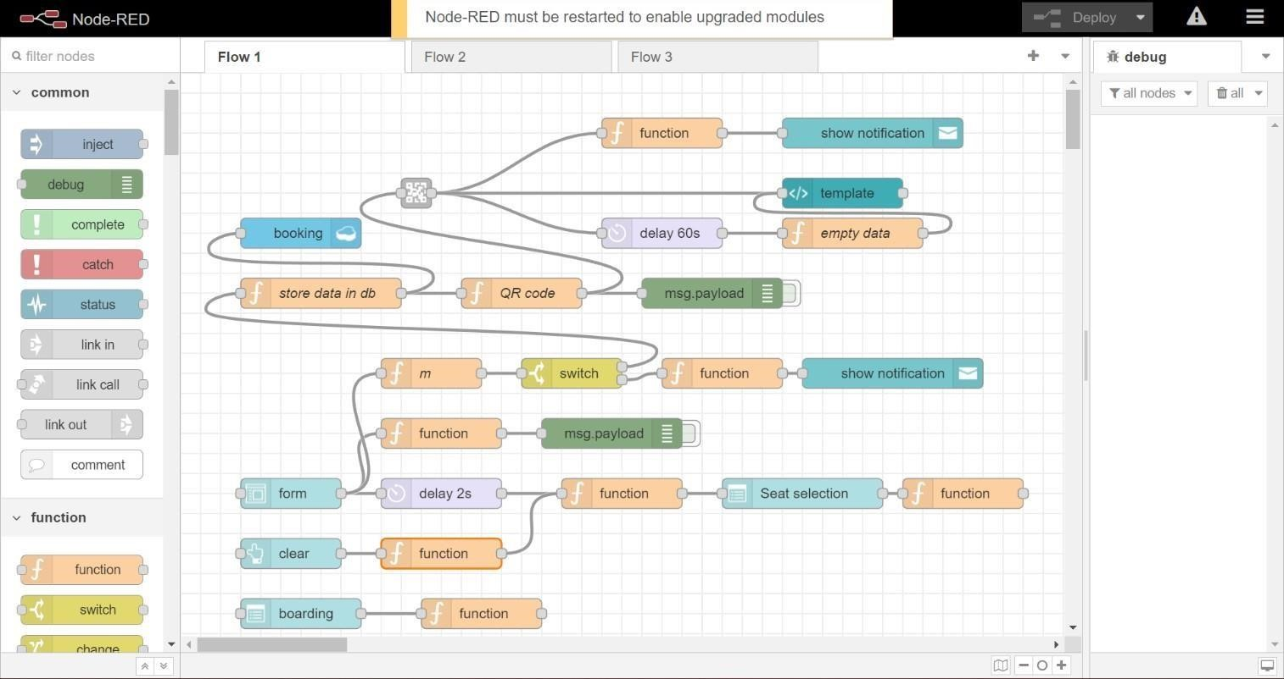

|  |
| --- |
| **FUNCTION NODE COMMAND TO INDICATE THE AVAILABLE SEATS:**    var a = global.get('a') for (let i=0; i<a.length; i++){ s.push(a[i]) } if(s.length==0) {  msg.options = [{“No Seats Available”:0}]  } else {  msg.options = s  }  msg.payload = s return msg; |
| **FUNCTION NODE COMMAND TO INDICATE THE AVAILABLE SEATS:**    var s = global.get('s') var a = global.get('a') function reg (x){  for (let i=0; i<a.length; i++){ if(a[i]==x) {  a.splice(i,1)  }  }  } if  (s==1) {  global.set (‘s1’, s)  reg (s)  }  else if (s==2) { global.set (‘s2’, s)  reg (s)  }  else if (s==3) { global.set (‘s3’, s)  reg (s)  }  else if (s==4) { global.set (‘s4’, s)  reg (s)  }  return msg; |

**FORM DETAILS:**

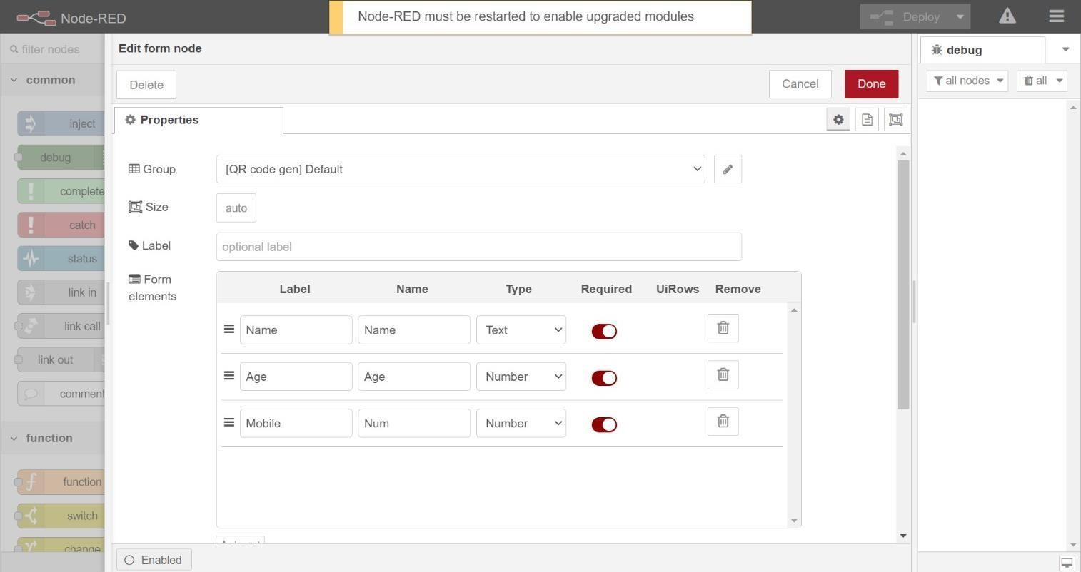

|  |
| --- |
| **FUNCTION NODE COMMAND TO STORE DATA IN DATABASE:**    var m = global.get ('m') var d = new Date ();  var utc = d.getTime() + (d.getTimezoneOffset()*60000); var offset = 5.5;  newDate = new Date (utc+(3600000*offset)); var n = newDate.toISOString() var date =  n.slice (0,10) var time = n.slice (11,19) var d1 = date + ',' + time msg.payload = {  "_id": d1,  "Name": m.Name, "Age": m.Age,  "Mobile": m.Num,  "boarding": global.get('b'),  "destination": global.get('d'),  "Seat":global.get('s')  }  return msg; |

**SEAT DROPDOWN BOX:**

